**LAB 4(22K-5192)**

**Task 1:**

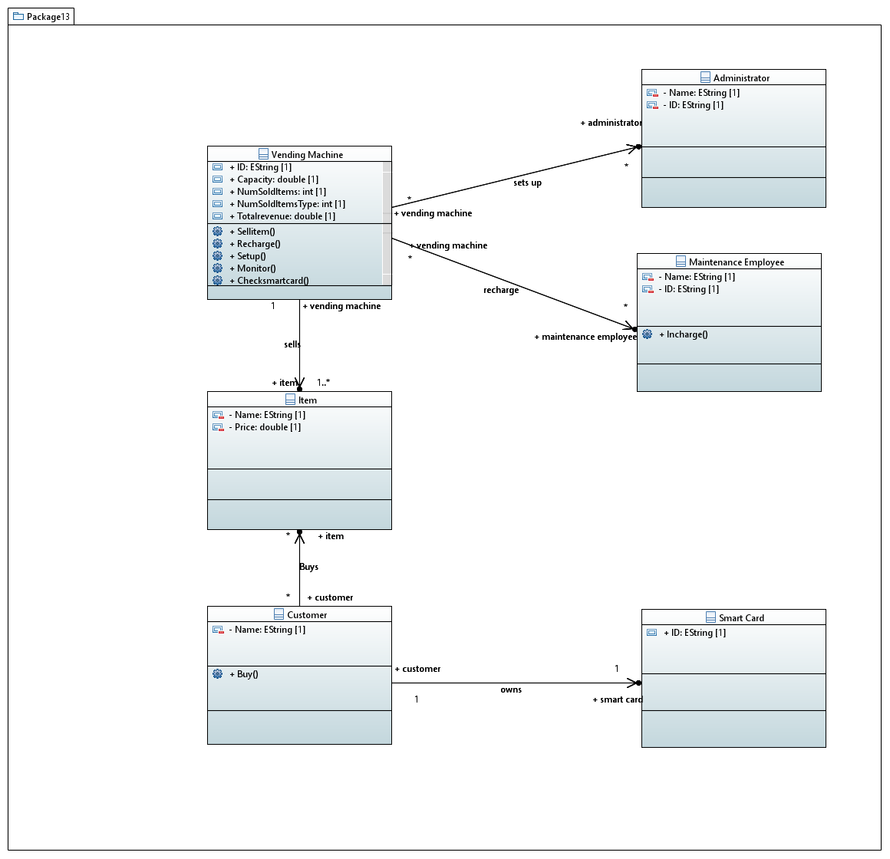

CODE(TASK 1):

**package** Package13;

**import** java.util.List;

**public** **class** Administrator {

/**

*

*/

**private** String Name;

/**

*

*/

**private** String ID;

/**

* Getter of Name

*/

**public** String getName() {

**return** Name;

}

/**

* Setter of Name

*/

**public** **void** setName(String Name) {

**this**.Name = Name;

}

/**

* Getter of ID

*/

**public** String getID() {

**return** ID;

}

/**

* Setter of ID

*/

**public** **void** setID(String ID) {

**this**.ID = ID;

}

}

**public** **class** Customer {

/**

*

*/

**private** String Name;

/**

*

*/

**public** List<Item> item;

**public** SmartCard smartcard;

/**

* Getter of Name

*/

**public** String getName() {

**return** Name;

}

/**

* Setter of Name

*/

**public** **void** setName(String Name) {

**this**.Name = Name;

}

/**

* Getter of item

*/

**public** List<Item> getItem() {

**return** item;

}

/**

* Setter of item

*/

**public** **void** setItem(List<Item> item) {

**this**.item = item;

}

}

**public** **class** Item {

/**

*

*/

**private** **double** Price;

/**

*

*/

**private** String Name;

/**

* Getter of Price

*/

**public** **double** getPrice() {

**return** Price;

}

/**

* Setter of Price

*/

**public** **void** setPrice(**double** Price) {

**this**.Price = Price;

}

/**

* Getter of Name

*/

**public** String getName() {

**return** Name;

}

/**

* Setter of Name

*/

**public** **void** setName(String Name) {

**this**.Name = Name;

}

}

**public** **class** SmartCard {

/**

*

*/

**public** String ID;

/**

* Getter of ID

*/

**public** String getID() {

**return** ID;

}

/**

* Setter of ID

*/

**public** **void** setID(String ID) {

**this**.ID = ID;

}

}

**public** **class** VendingMachine {

/**

*

*/

**public** List<MaintenanceEmployee> maintenance;

/**

*

*/

**public** **int** NumSoldItemsType;

/**

*

*/

**public** **double** Capacity;

/**

*

*/

**public** List<Administrator> administrator;

/**

*

*/

**public** List<Item> item;

/**

*

*/

**public** String ID;

/**

*

*/

**public** **double** Totalrevenue;

**public** **int** NumSoldItems;

}

**public** **class** MaintenanceEmployee {

/**

*

*/

**private** String ID;

/**

*

*/

**private** String Name;

/**

* Getter of ID

*/

**public** String getID() {

**return** ID;

}

/**

* Setter of ID

*/

**public** **void** setID(String ID) {

**this**.ID = ID;

}

/**

* Getter of Name

*/

**public** String getName() {

**return** Name;

}

/**

* Setter of Name

*/

**public** **void** setName(String Name) {

**this**.Name = Name;

}

/**

*

*/

**public** **void** Incharge() {

// **TODO** Auto-generated method

}

}

**TASK 2:**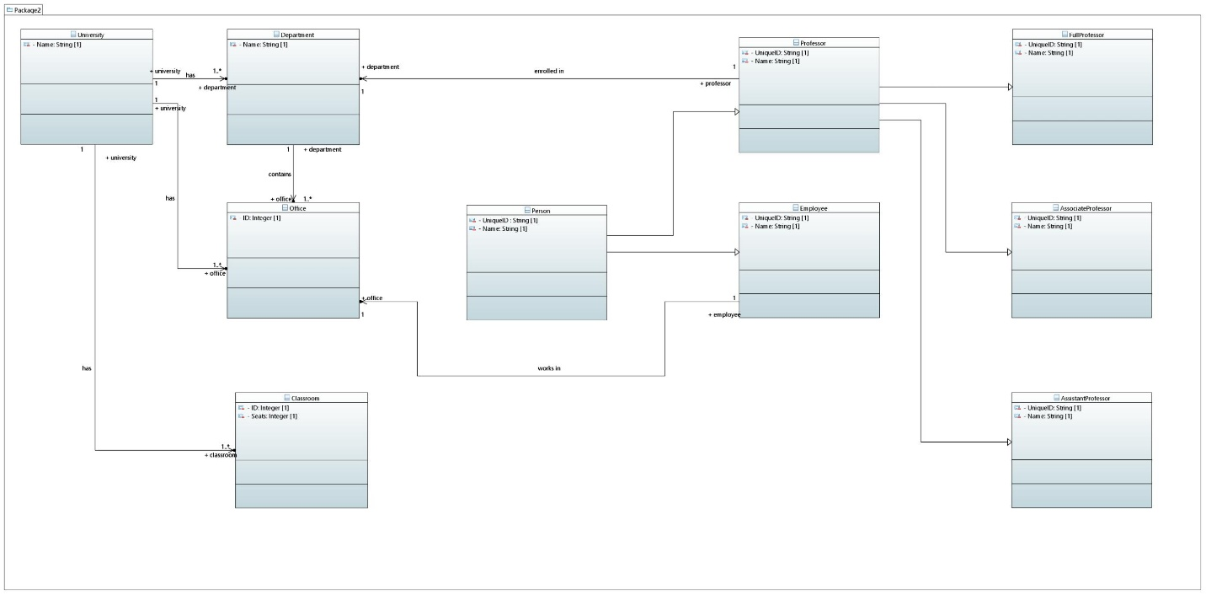

**TASK 3:**

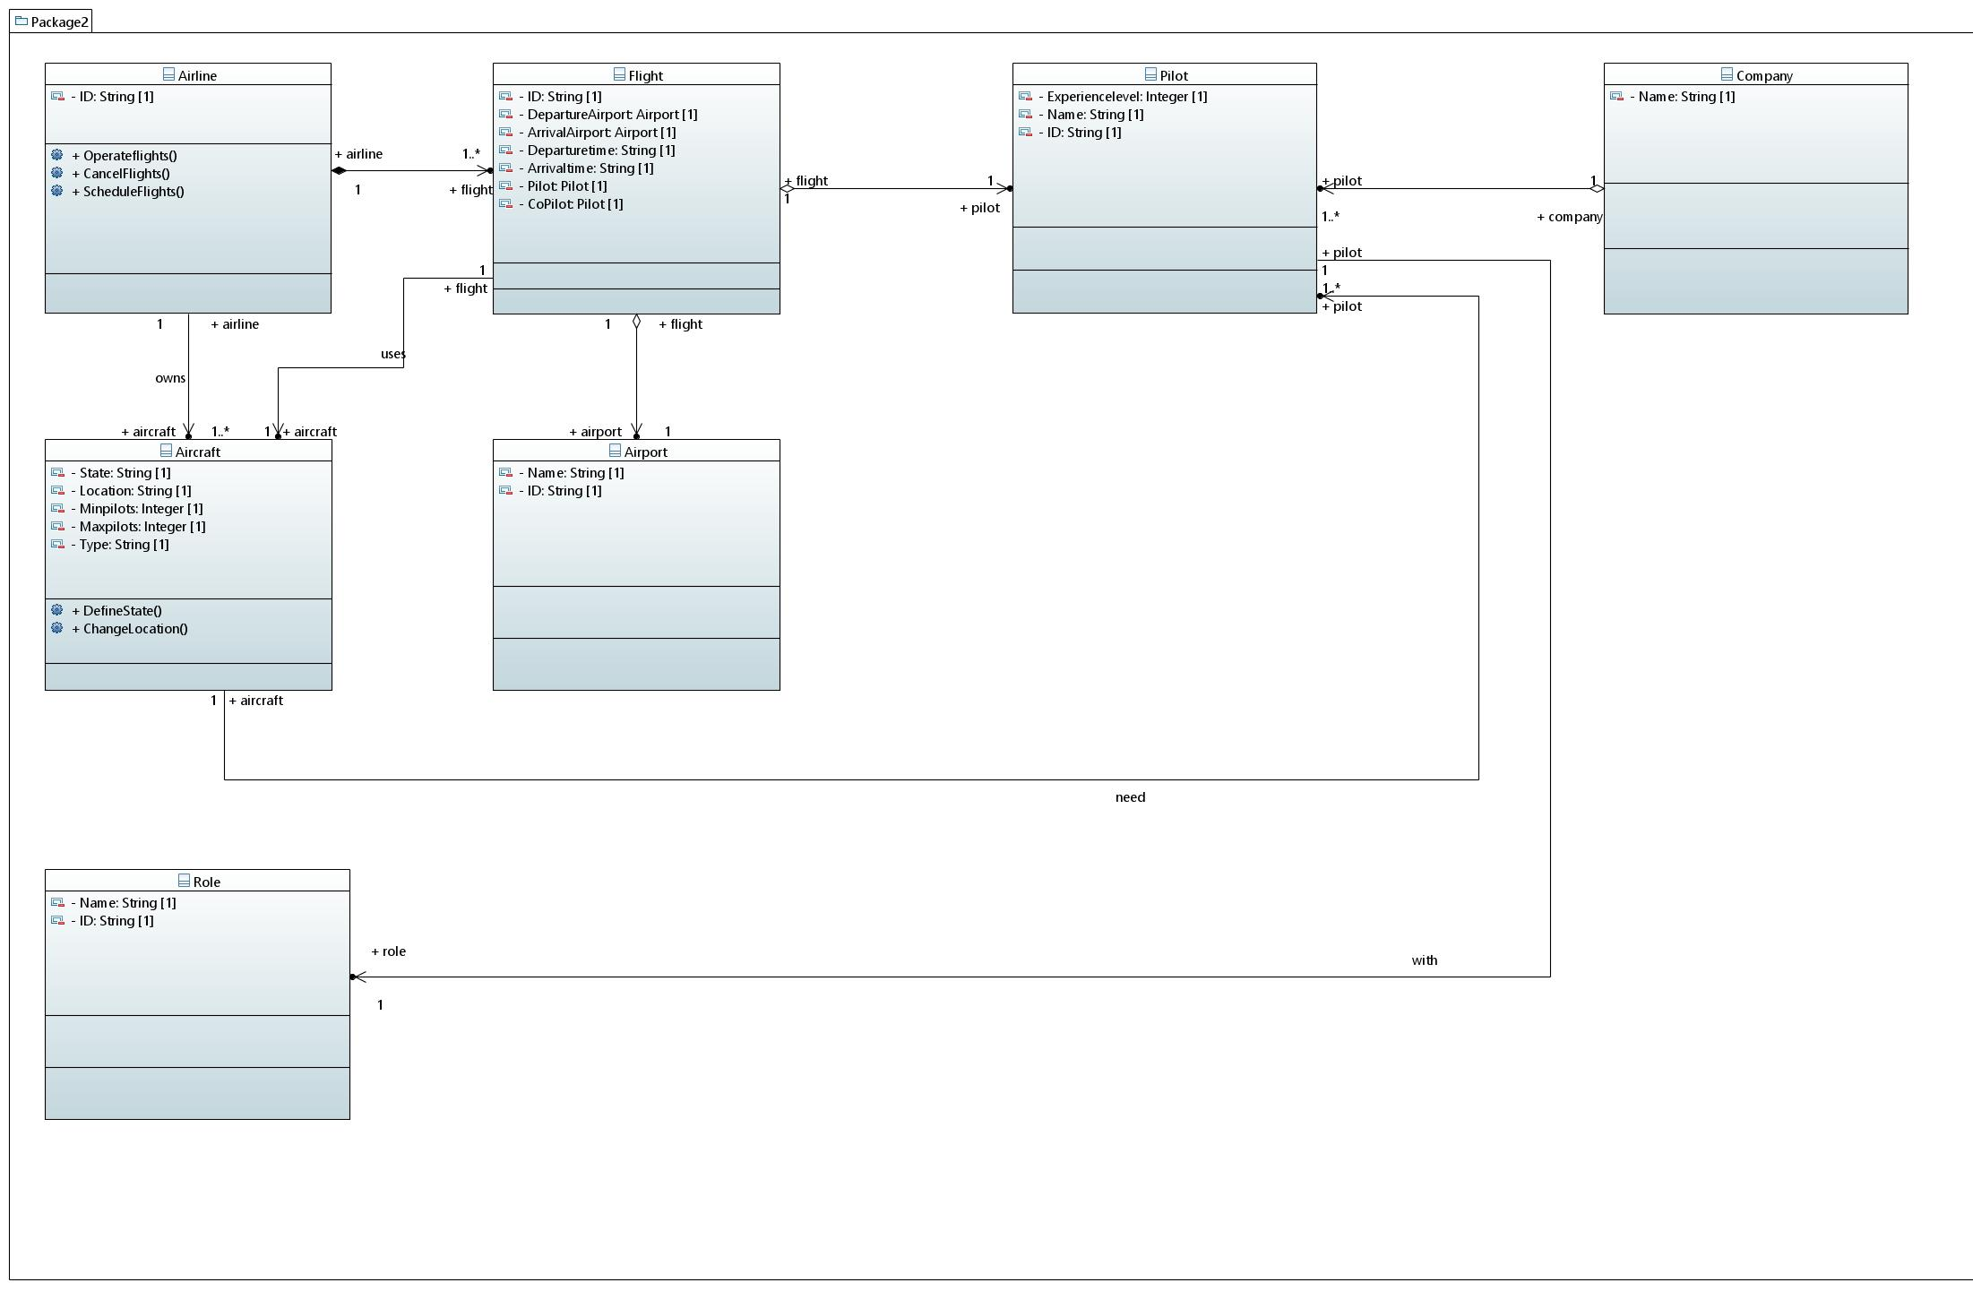

**TASK 4:**

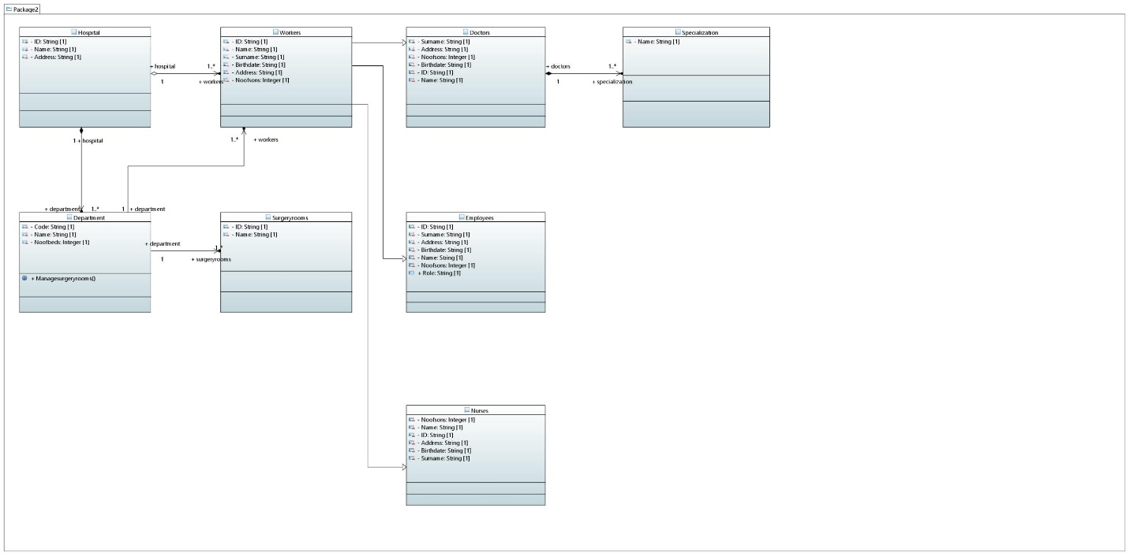

**TASK 5:**

